**INVENTORY MANAGEMENT SYSTEM**

by

Khushi Mattu 20BCE1189

Madhur Singh 20BPS1116

Sneha Makesh 20BCE1739

A project report submitted to

**Dr. Balasundaram A**

**SCOPE**

In fulfilment of the requirements for the course of

**CSE2004 – Database Management Systems**

In

**B.Tech Computer Science and Engineering**



**Vandalur – Kelambakkam Road**

**Chennai – 600127**

**JUL 2021**

**BONAFIDE CERTIFICATE**

Certified that this project report entitled “**Inventory Management System”**is a bonafide work of **Khushi Mattu(20BCE1189), Madhur Singh(20BPS1116), Sneha Makesh(20BCE1739)** who carried out the Project work under my supervision and guidance for **CSE2004 – Database Management Systems.**

**Dr. Balasundaram A.**

Assistant Professor (Sr.)

SCOPE

VIT University, Chennai

Chennai – 600 127.

**TABLE OF CONTENTS**

|  |  |  |
| --- | --- | --- |
| **SL. NO.** | **TITLE** | **PAGE NO.** |
| 1. | ABSTRACT | 3 |
| 2. | ACKNOWLEDGEMENT | 4 |
| 3. | INTRODUCTION | 5 |
| 4. | ER DIAGRAM | 6 |
| 5. | ER TO RELATIONAL MAPPING | 7 |
| 6. | IMPLEMENTATION | 8 |
| 6. | EXPERIMENTAL SETUP (HARDWARE & SOFTWARE SPECIFICATIONS ) | 9 |
| 7. | EXPERIMENTAL RESULTS DISCUSSION | 10 |
| 8. | CONCLUSION AND FUTURE WORK | 14 |
|  | REFERENCES | 15 |
|  | APPENDIX 1 (SQL QUERIES) | 16 |
|  | APPENDIX 2 (Relevant Screenshots and code zip file) | 21 |

**ABSTRACT**

As one’s business increases, knowing when to reorder, how much to order, where to store stock, and so on can quickly become a complicated process. With the increasing amount of data every second the online shopping sector, industries even the IT companies are facing a lot of problem not only in storing the data but also how to keep it intact.

Usually an inventory system has various tables like Warehouse, Raw Materials, Suppliers and Employees which makes it hectic for the admin to store all of these data and the relation between them.

This system provides an efficient way of storing, deleting, searching, updating the data from these modules.

**ACKNOWLEDGEMENT**

We wish to express our sincere thanks and deep sense of gratitude to our project guide, **Dr. Balasundaram A.,**Assistant Professor (Sr.), SCOPE, for his consistent encouragement and valuable guidance offered to us in a pleasant manner throughout the course of the project work.

        We also take this opportunity to thank all the faculty of the School for their support and their wisdom imparted to us throughout the course.

        We thank our parents, family, and friends for bearing with us throughout the course of our project and for the opportunity they provided us in undergoing this course in such a prestigious institution.

Khushi Mattu Madhur Singh Sneha Makesh

**INTRODUCTION**

Inventory management is how you track and control your business’ inventory as it is bought, manufactured, stored, and used. It governs the entire flow of goods — from purchasing right through to sale — ensuring that you always have the right quantities of the right item in the right location at the right time.

As a part of supply chain, Inventory management includes aspects such as:

* Controlling and overseeing purchases from suppliers as well as customers
* Maintaining the storage of stock
* Controlling the amount of product for sale
* Order fulfilment.

Inventory management dictates how one runs a business, serve customers and grow sales. For businesses based around selling products (which in our case is mainly electronics) managing inventory efficiently is crucial.

**ER DIAGRAM**

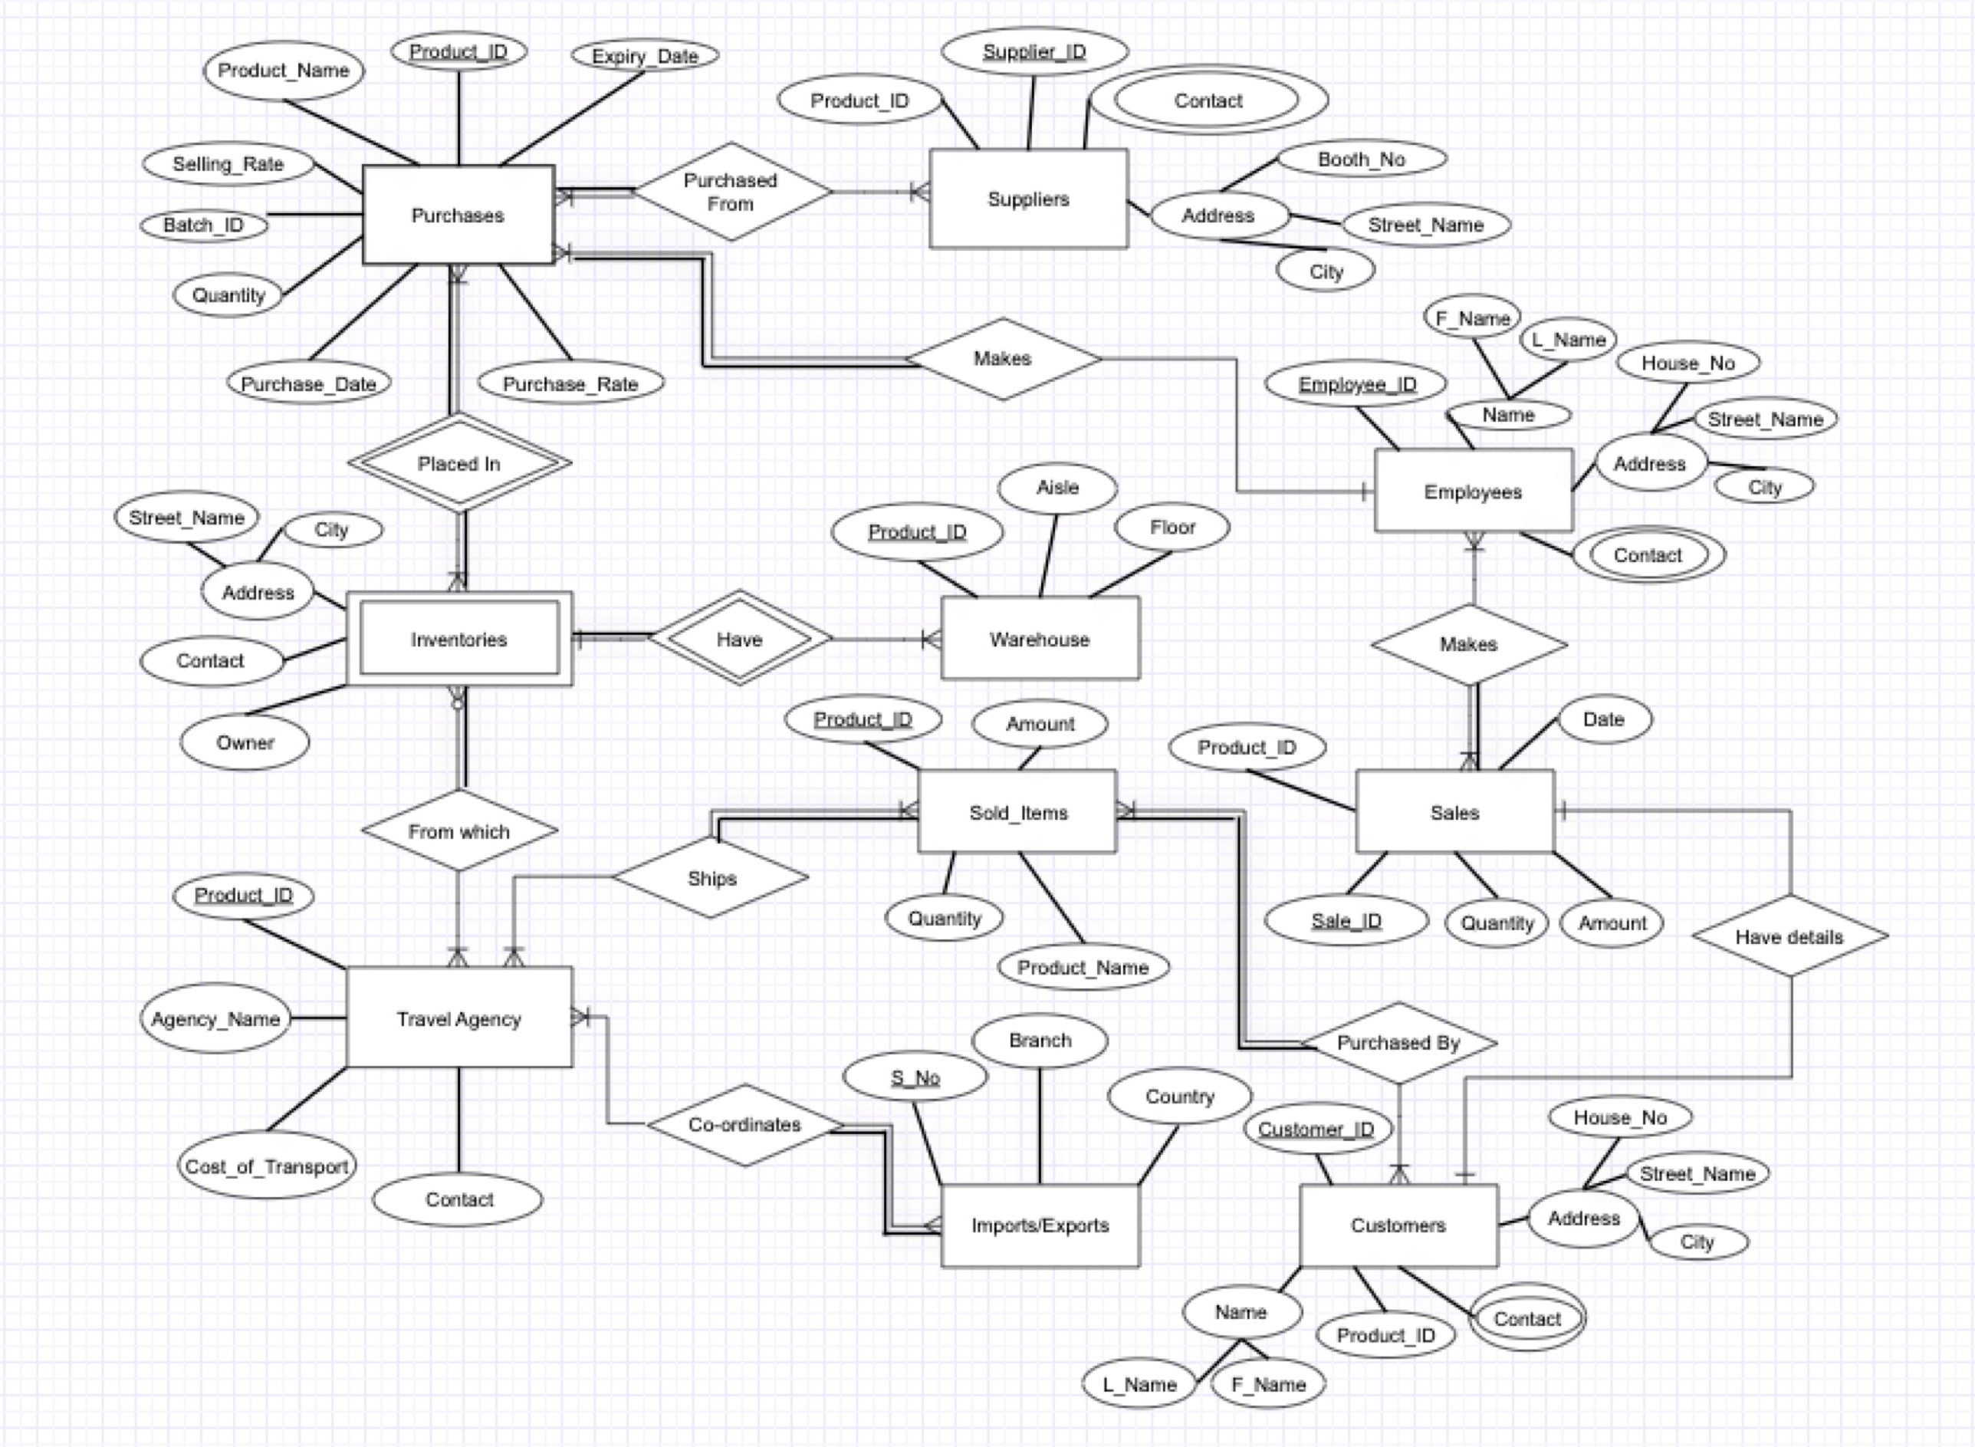

**ER TO RELATIONAL MAPPING**

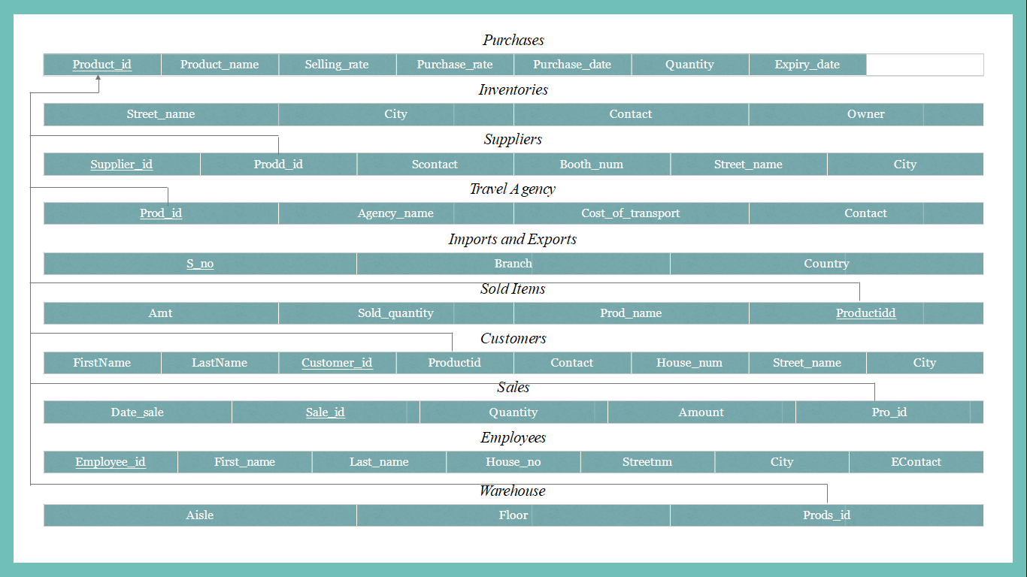

**IMPLEMENTATION**

The detatailed description of the tables as follows.

Firstly we have the purchases table it is unquiely identified by product_id attribute. Other attributes contains are product_name, selling_rate,purchase_rate ,purchase_date , quantity,expiry_date ,batch_id . it has a primary key product_id connecting to travel agency, customers,sales,sold items,warehouse,suppliers.

Next we come to inventories table and it is identified by street_name,city ,contact number and owner. It doesn’t have any primary or foreign key. It is one of the main tables of our database.

Then we come to travel agency table , which has its foreign key product_id reference from purchases it also has attributes such as agency_name ,cost_of_transport ,contact number.

Next coming to imports and exports table it has its primary key being serial no and its other attributes being branch and country .

Then we come to Customers table it has its own primary key being customer_id and a foreign key being product_id references from purchases, Its other attributes include firstname ,lastname ,contact number, house_num ,street_name ,city.

Next is the Sales table which has it own primary key sale_id and foreign key being product id reference from purchases and its identified with attributes date_sale,quantity and amount.

Next we come to table sold_items which has a foreign key product_id references from purchases and its other attributes being amt, sold_quanity and prod_name .

Then is table Employees which has its own primary key employee_id and its other attributes being first_name ,last_name ,house_no ,streetnm ,city and contact number.

Then is table Warehouse which as a foreign key being product is references from purchases and is identified with its other attributes like aisle and floor.

lastly we have Suppliers table which has its own primary key being supplier_id and a foreign key being product_id references from purchases and is identified with its other attributes being scontact, booth_num ,street_name and city.

**EXPERIMENTAL SETUP**

Hardware Specifications:

➤ Operating System: Windows 10 (64 BIT)

➤ RAM Capacity: 8GB DDR4 RAM

➤ Processor: Intel i5 (10th Generation)

➤ Graphics Processing Unit: MX250

Software Specifications:

➤ Front-End: Python with tkinter module

➤ Back-End: Oracle / MySQL

**EXPERIMENTAL RESULTS DISCUSSION**

**Login Page**

This is the login page where the users can login with their respective username sand passwords.

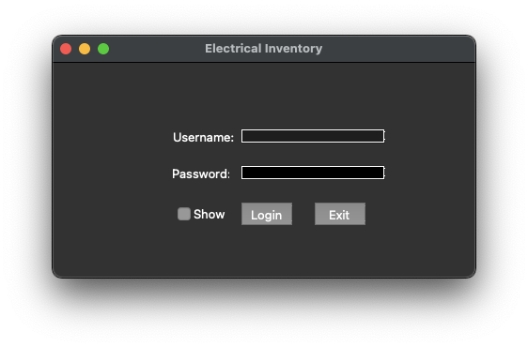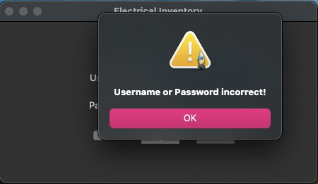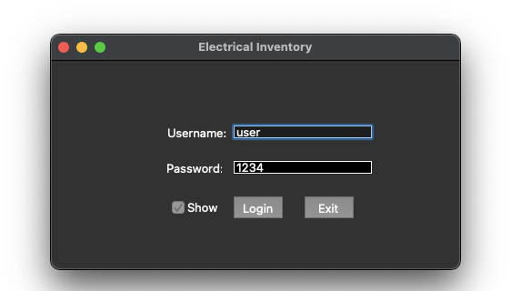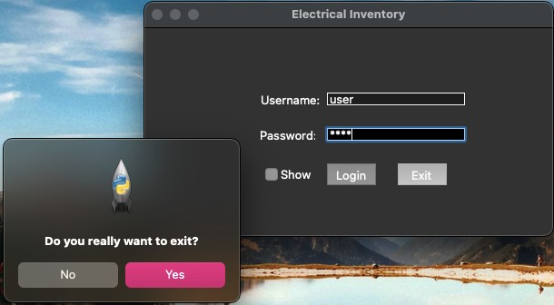

**Frontend**

This is how our frontend looks. We can see four tables from our database are attached to the frontend-employee, purchases, customers and inventories.

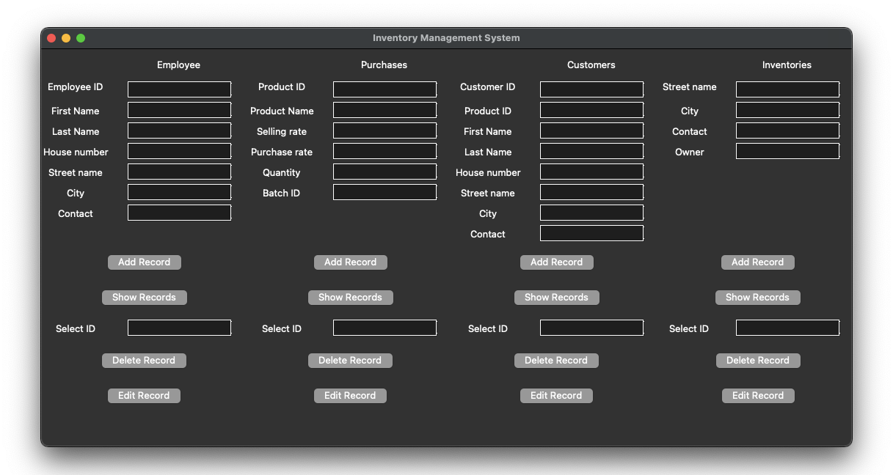

This is how we can add a record to a particular table. After filling the required information we have to click add record.

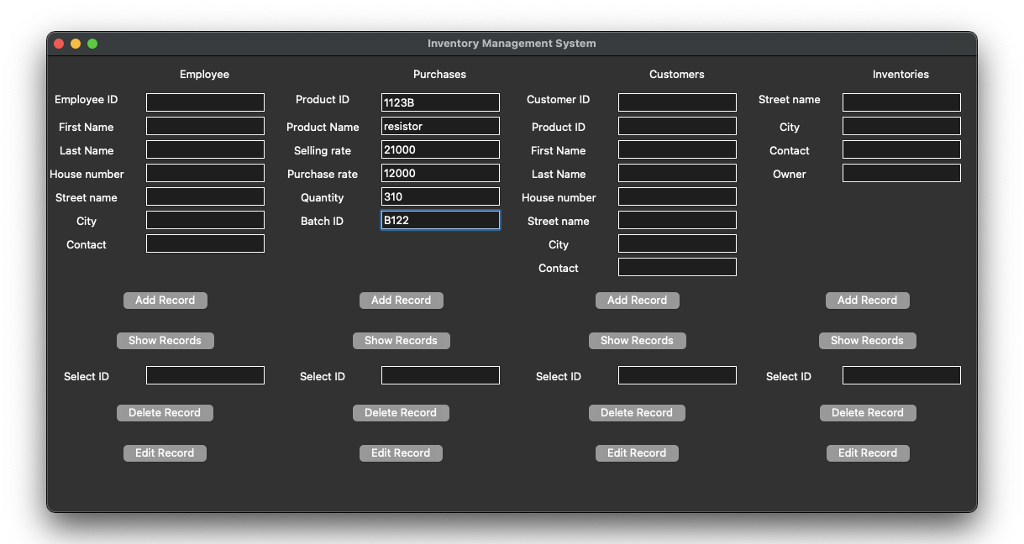

By clicking on show record we will be able to see the record we have added.

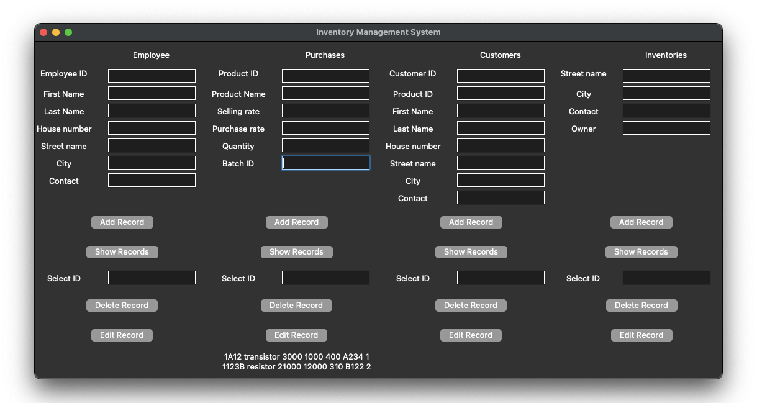

To update a record, we can click enter the id whose information we have to edit and then select edit record fill out the required information and then click save record to save the changes.

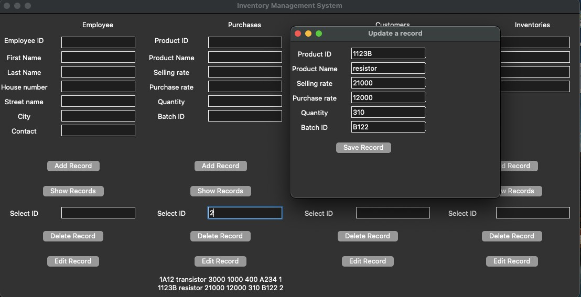

By clicking on show record, we can see the changes done.

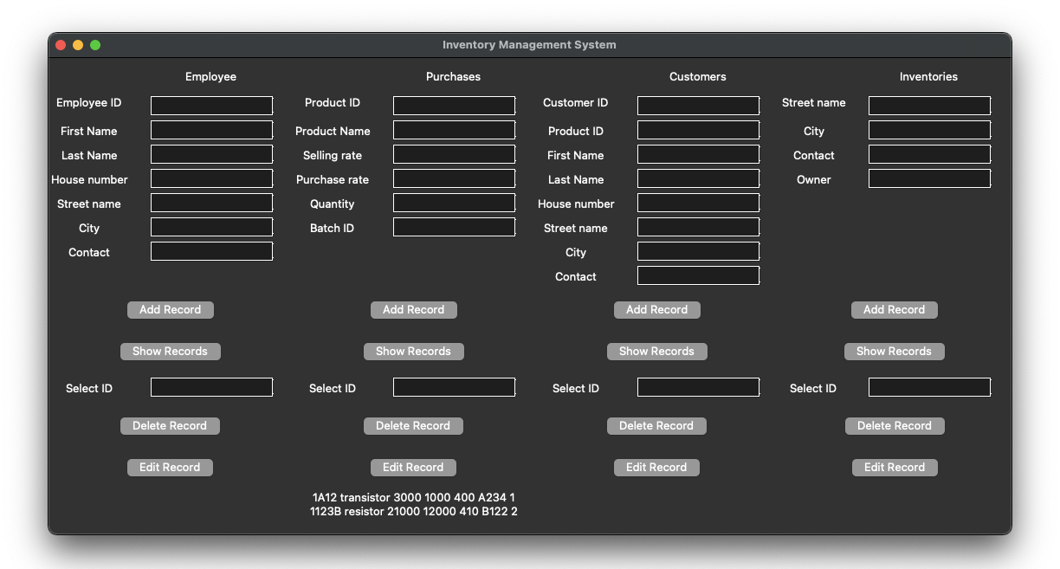

To delete a record, we have to select the id whose information we want to remove from the database and then click on delete record.

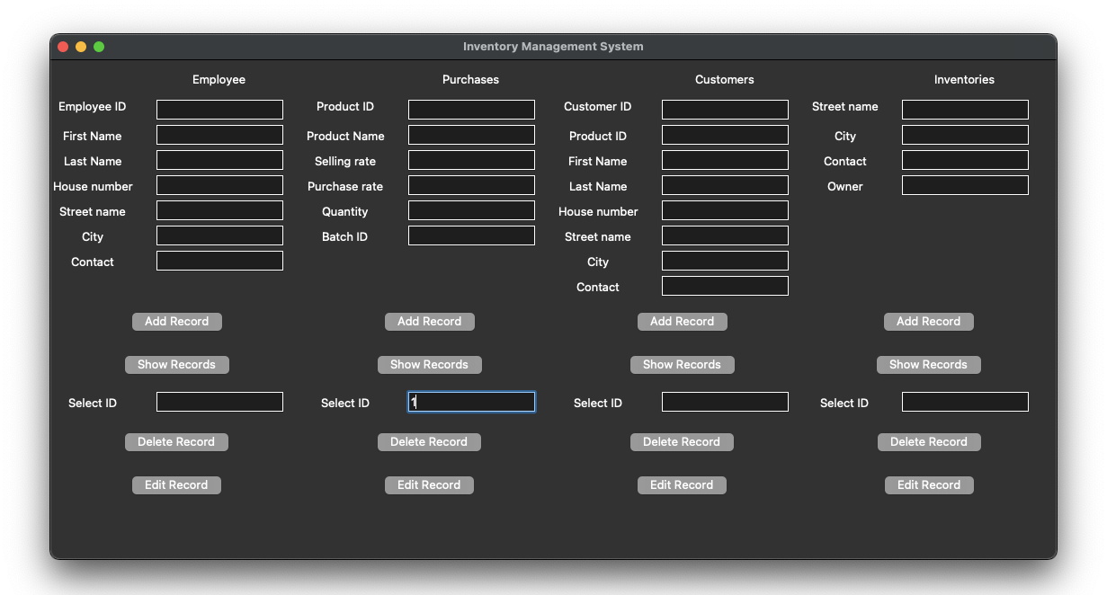

By clicking on show record, we can see that one record has been deleted.

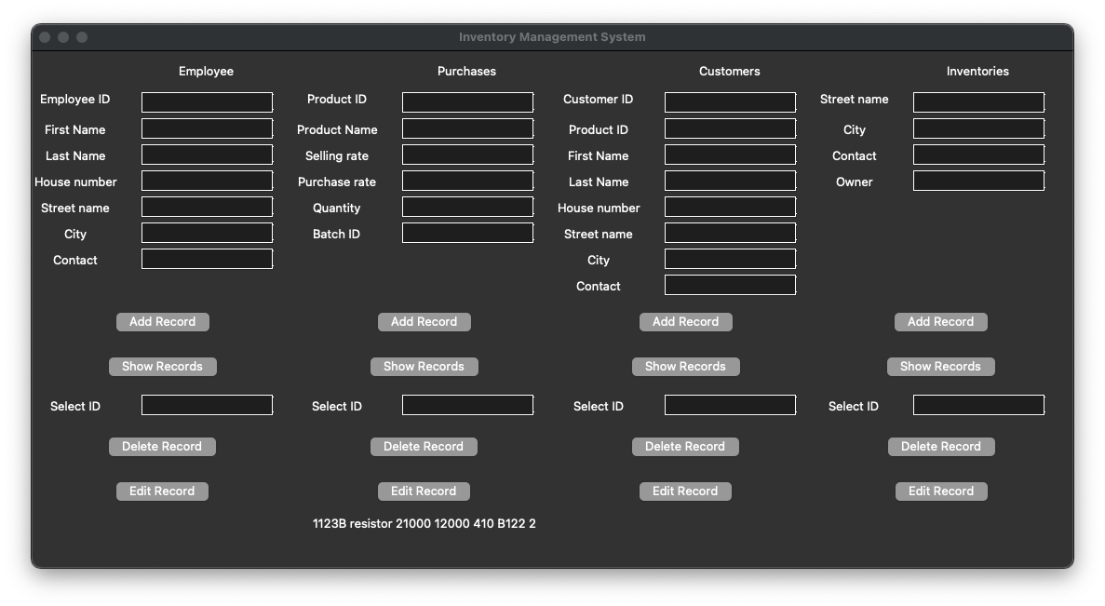

**CONCLUSION AND FUTURE WORK**

To conclude, inventory management system is just a simple desktop application which can be used by small companies. Since this is our first project it has some limitations due to less

knowledge in some particular fields. But our project has all the basic items which are needed for a small organisation. Our team is successful in making the application where we can

update, insert and delete as per requirement. Our application is easy to access and user

friendly. The applications also keeps a backup for all the employee, salesman, customer, etc ‘s details.

We hope that this project can help the organisation.

**REFERENCES**

1. <https://www.youtube.com/watch?v=Iy72DEgAtT0>
2. <https://cbsetoday.com/inventory-system-python-project/>
3. <https://www.youtube.com/watch?v=g60QghtJmjY>
4. <https://www.youtube.com/watch?v=AK1J8xF4fuk>
5. <https://stackoverflow.com/questions/58432120/how-to-open-main-window-after-successful-login>

**APPENDIX I**

create database inventory;

use inventory;

**Table purchases**

CREATE TABLE PURCHASES(product_id varchar(20) not null primary key,product_name varchar(20),selling_rate int,purchase_rate int,purchase_date date, quantity int,expiry_date date,batch_id varchar(20));

INSERT INTO PURCHASES VALUES('1122A','capacitor',20000, 10000,'14-12-19',300,'29-12-25','A121');

INSERT INTO PURCHASES VALUES('1123B','resistor',21000, 12000,'13-01-18',310,'24-01-24','B122');

INSERT INTO PURCHASES VALUES('1123C','resistor',15000, 8000,'11-10-19',150,'29-11-23','B123');

INSERT INTO PURCHASES VALUES('1131D','M-F-JUMPER',2000, 1000,'05-03-17',500,'22-12-22','C182');

INSERT INTO PURCHASES VALUES('1124D','F-F-JUMPER',20100, 10200,'14-11-19',320,'29-12-23','E213');

SELECT * FROM PURCHASES;

**Table Suppliers**

CREATE TABLE SUPPLIERS(supplier_id varchar(20) not null primary key, prodd_id varchar(20), foreign key(prodd_id) references PURCHASES(product_id), scontact varchar(20), booth_num int, street_name varchar(20), city varchar(20));

INSERT INTO SUPPLIERS VALUES('111A','1122A','9874635462',1,'add1','chennai');

INSERT INTO SUPPLIERS VALUES('112B','1123B','9878567465',2,'add2','Delhi');

INSERT INTO SUPPLIERS VALUES('113C','1123C','9478567435',3,'add3','Goa');

INSERT INTO SUPPLIERS VALUES('123D','1131D','8211443293',4,'add4','Mumbai');

INSERT INTO SUPPLIERS VALUES('143E','1124D','7007847499',5,'add5','Delhi');

SELECT * FROM SUPPLIERS;

**Table Inventories**

CREATE TABLE INVENTORIES(street_name varchar(30), city varchar(20), contact varchar(20), owner varchar(20));

INSERT INTO INVENTORIES VALUES('addA', 'Delhi', '9656473645', 'owner1');

INSERT INTO INVENTORIES VALUES('addB', 'Chennai', '8785746372', 'owner2');

INSERT INTO INVENTORIES VALUES('addC', 'Mumbai', '6746573823', 'owner3');

INSERT INTO INVENTORIES VALUES('addD', 'Allahabad', '8957463212', 'owner4');

INSERT INTO INVENTORIES VALUES('addE', 'Goa','7856473623', 'owner5');

SELECT * FROM INVENTORIES;

**Table Imports Exports**

CREATE TABLE imports_exports(sno int not null primary key, branch varchar(45), country varchar(45));

desc imports_exports;

insert into imports_exports values(290424, 'Tokyo', 'Japan');

insert into imports_exports values(738465, 'Chennai', 'India');

insert into imports_exports values(853462, 'California', 'USA');

insert into imports_exports values(193846, 'London', 'UK');

insert into imports_exports values(496453, 'Sydney', 'Australia');

select * from imports_exports;

select * from PURCHASES;

**Table Travel Agency**

create table travelAgency(prod_id varchar(20), foreign key (prod_id) references PURCHASES(product_id),

agency_name varchar(30), cost int(8),contact int(10));

insert into travelAgency values('1131D', 'Happy travels', 124000, 984566323);

insert into travelAgency values('1123C', 'AA travels', 290000, 674832709);

insert into travelAgency values('1123B', 'marshall travels', 90000, 874645530);

insert into travelAgency values('1122A', 'flybird travels', 545000, 967845329);

insert into travelAgency values('1124D', 'hourglass travels', 320000, 957483625);

**Table Sold Items**

create table sold_items(amnt int, soldQuantity int, prod_name varchar(30),

idproduct varchar(30), foreign key (idproduct) references PURCHASES(product_id));

insert into sold_items values(105000, 1, 'resistor', '1123C');

insert into sold_items values(1130000, 2, 'capacitor', '1122A');

insert into sold_items values(90000, 1, 'resistor', '1123C');

insert into sold_items values(320000, 1, 'F-F-JUMPER', '1124D');

insert into sold_items values(290000, 1, 'resistor', '1123C');

**Table Warehouse**

create table WareHouse(aisle int, floor int, prods_id varchar(30),

foreign key (prods_id) references PURCHASES(product_id));

insert into WareHouse values(17, 1, '1123B');

insert into WareHouse values(12, 2, '1122A');

insert into WareHouse values(27, 2, '1131D');

insert into WareHouse values(9, 3, '1124D');

insert into WareHouse values(3, 4, '1123C');

**Table Customers**

create table Customers(customer_id varchar(20) not null primary key,productid varchar(20), foreign key (productid) references purchases(product_id) ,firstname varchar(20),lastname varchar(20),contact int ,house_num int,street_name varchar(20),city varchar(20));

insert into Customers values ('A51C','1122A','Akshat','Jain',967535476,34,'MG road', 'Chandigarh');

insert into Customers values ('D33G','1123B','sunil','Jha',778964353,45,'mall road','Kota');

insert into Customers values ('C11H','1123C','Khushi','Dutta',999987654,23,'park street','Kolkata');

insert into Customers values ('A67E','1131D','Sanjay','bhasin',900886574,76,'linking road','Pune');

insert into Customers values ('H97T','1124D','Riya','chauhan',899112335,21,'Arcot road','Chennai');

select * from Customers;

**Table Sales**

create table sales( Sale_id varchar(20) not null primary key,pro_id varchar(20), foreign key (pro_id) references purchases(product_id) , date_sale date, quantity int, amount int );

insert into sales values ('S324','1122A','25-03-19',10,200000);

insert into sales values ('S659','1123B','20-10-17',5,60000);

insert into sales values ('S631','1123C','28-02-19',7,56000);

insert into sales values ('S023','1131D','01-12-16',15,15000);

insert into sales values ('S268','1124D','12-04-19',10,102000);

**Table Employee**

create table Employee( Employee_id varchar(20) primary key, first_name varchar(20), Last_name varchar(20),House_no int,streetnm varchar(20),city varchar(20),contact int(10));

insert into Employee values ('A123B','Sanyam','Sharma',47,'ashok vihar','New Delhi',954763273);

insert into Employee values ('A654N','Kesav','Santosh',36,'SA road','Kochi',864900223);

insert into Employee values ('9GHS7','Neha','Gupta',40,'Sohna road','Gurgaon',569202536);

insert into Employee values ('2JKA9','Sonal','Das',54,'Yelahanka','Bangalore',958332782);

insert into Employee values ('1QWE8','Hardik','Singh',78,'Ranjit Avenue','Amritsar',967850031);

select * from Employee;

use inventory;

**APPENDIX II**

**Table Purchases**

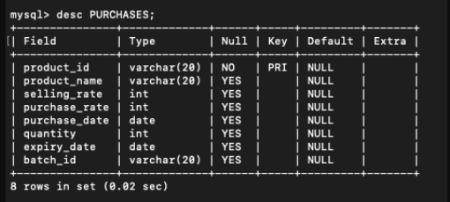

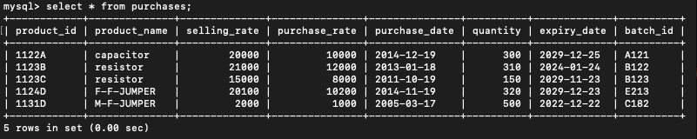

**Table Suppliers**

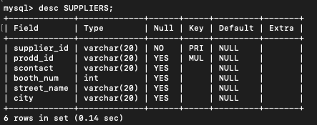

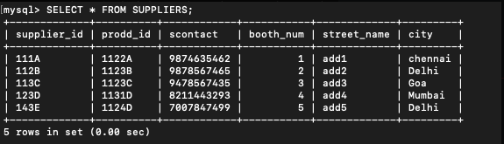

**Table Inventories**

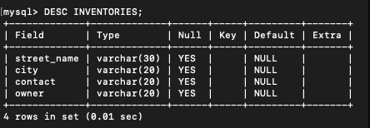

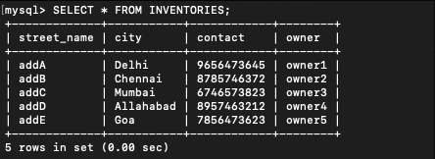

**Table imports_exports**

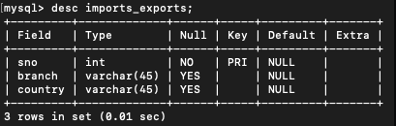

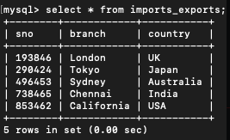

**Table travelAgency**

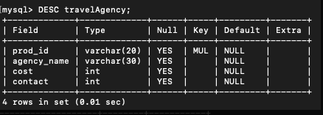

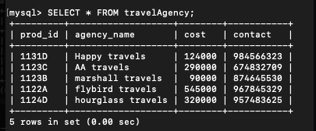

**Table sold items**

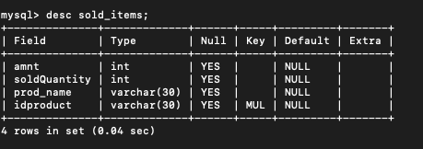

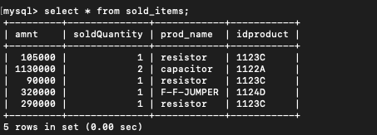

**Table Customers**

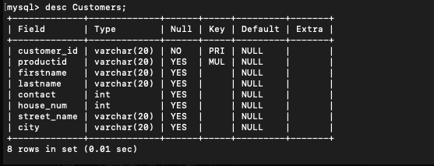

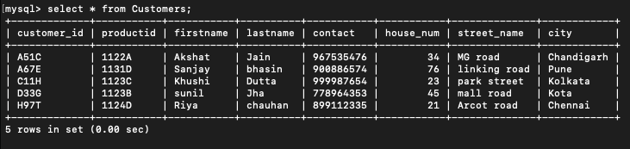

**Table sales**

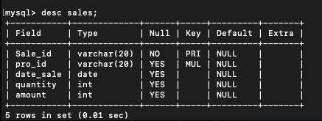

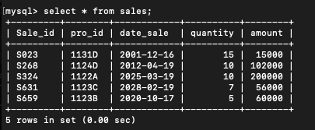

**Table employee**

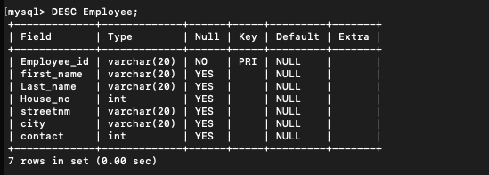

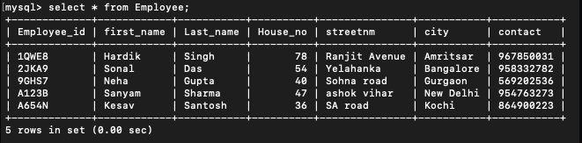

**Table Warehouse**

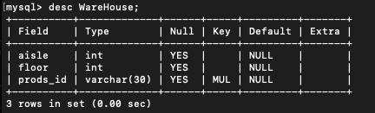

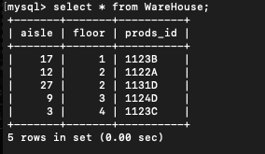

[**Press CTRL + Click to access the source codes**](https://github.com/MadhurSingh07/dbms-project-inventory-management)